# Step by step analysis done so far and future avenues to take!

**Google drive info.**

<https://drive.google.com/drive/folders/165ty0xhrsfbp2ao_ARYNorLILVTjbpzl?usp=sharing>

Full_script_data2013GPS_IS_model.R (this script can be found in: <https://drive.google.com/file/d/15xHegNnqNyBlPeFSLa9RY3W44m1Pg0Ob/view?usp=sharing>)

Existing Wandering albatross 2013 Crozet GPS data (89 bird ID, 89 trips. Second and third trips made from same bird ID are shorter so are not including them R script lines 56-305). Specifically, **GPS** data points (latitude and longitude) and **UTC time** collected **every 15 minutes**. For each bird ID the sex of the bird will be used. GPS maps plots colored by time since departure are in folder gps_maps <https://drive.google.com/drive/folders/1dmV1uI9D-OCm5zblNqM1ozXQ3FBlo0UE?usp=sharing>. Gif GPS & SPL maps can be found in folder gif_2013_spl <https://drive.google.com/drive/folders/1vaDmMvcUTWTOFdp1nnKJwTFtixGMKx4A?usp=sharing>. GPS data given to Ollie to perform the SPL maps can be found in folder gps_2013_data <https://drive.google.com/drive/folders/1dmV1uI9D-OCm5zblNqM1ozXQ3FBlo0UE?usp=sharing>

* + Estimate the distance to the Crozet Shelf (R script lines 149-202) and remove all GPS points that are less than 10km from the Crozet shelf only at the beginning and at the end of the trip but not in the middle of the trip. (R script lines 314-371) GPS plot figures without those points closer than 10km from the Crozet shelf can be found in folder “HMM files_GPS_2013\Re _Redo_models_to_extract_GPS2013_Crozet_data\GPS plot data near colony filtering datapoints 10km from shore” <https://drive.google.com/drive/folders/1vaDmMvcUTWTOFdp1nnKJwTFtixGMKx4A?usp=sharing>
  + Based on the distance and turning angle between consecutive GPS points, GPS data has been already classified in the following behaviours using HMM: resting, searching, and travelling. Good HMM residuals. (R script lines 373-515) Output figures can be found in folder “HMM files_GPS_2013” and within this one in “Output HMM plots_nozero”. <https://drive.google.com/drive/folders/1a6X2BQH3-TqTsh5__7Xls-IaskhrJBHD?usp=sharing>
  + Each trip has been divided in 3 states: out (moving out of the colony), middle (middle part of the trip normally the birds are foraging or searching), and in (moving towards the colony). This classification has been done at the population level following Wakefield et al. (2009). See appendix for more detail regarding the analysis. (R script lines 539-658). Figures and documentation can be found in folder “Trip_state_thresdhold_population” <https://drive.google.com/drive/folders/19lDXZnj4d-7f2RFYsMKEbN5Ph8BwU4Mf?usp=sharing> (Before this decision was taken, we explored the possibility that wandering albatross could home, see folder “Check_homming” <https://drive.google.com/drive/folders/1nBrbZMjSLaaFqopVdZJgCiZuL3xWvS-i?usp=sharing>. We also explored the possibility of divide trips using Kernels, see folder “Kernel” <https://drive.google.com/drive/folders/1F7xdj_KTA2UPLi718voTNxzo6_X8fee7?usp=sharing>)

While we are not specifically looking at homing, we have reason to believe that birds might be using IS differently for different portions of trips as their motivations change. Perhaps we could include an effect/interaction with time along trip to see if birds are more likely to respond more towards the final portions or add a covariable that describes the amount of time spent travelling. E.g., the motivations of the animal may be affected by the last time it searches for food withing the dive.

* + We have created travelling bouts defined as travelling periods longer than 20 km, as this seems to be the threshold for Wandering albatross to use their olfactory sense of smell (Nevitt et al., 2008). (R script lines 559-714). The idea is that when an individual is travelling for longer than 20 km they may be using other cues to travel, for example IS.

We need to do a sensitivity analysis changing this distance threshold to see if the results change or not in this regard. **(I have not done this**).

All the cone specific analysis is in (R script lines 715-1150). Soundscapes from Ollie can be found in <https://drive.google.com/drive/folders/1t1vWtpbgFv_kNWn7fXSzBjGQeicu4Jdq?usp=sharing>

* + We have selected the first point of each travelling bout and estimated the travelled distance in each bout and the travelled distance at that specific point. **For the first point of each travelling bout we have selected the associated IS map (i.e., the closest map within 30 minutes from the GPS datetime as only one IS map per hour has been done)**.
  + We have removed all of those maps for which any of the cones has a radius of less than 2000 km. So that all cones, and therefore all areas over which the SPL is estimated are the same.
  + We have divided the area around the bird (circle with a radius of 2000 km) in semicircles of 30 deg each to compare the focal semicircles with the rest 11 non focal semicircles. After speaking with Susana, 30 deg seems a reasonable angle for the IS in front they are integrating. (IS source up to 2000km and 3000km from the bird contribute to 95% and almost 100% of the total acoustic power, respectively). Done.
  + The total SPL within each semicircle has been calculated and standardized to compare the total SPL of the focal vs the non-focal cones. The standardized SPL has been done by standardizing all SPL values to mean zero and standard deviation of 1, then those with a value greater than 0 would have a greater SPL than the average and those with a negative value will have a lower SPL than the average. The distance between the bird and the 45dB contour for each semicircle has been estimated. Done.

The standardization of the SPL is done because there is a new soundscape map every hour which means that the absolute SPL is different from map to map.

* + This leads to a database that has 12 rows for each starting travelling point, as many rows as semicircles for each circle area around the bird. Columns: ID_circle (1, 1,1,1,1,1,1,1,1,1). ID_ semicircle (1, 2, 3, 4, 5, 6, 7, 8, 9, 10, 11, 12, being semicircle 1 the focal one and from there count from 2 to 12 clockwise). Selected (binomial 0 or 1; the focal semicircle will be a 1 while the other 11 non focal semicircles will have a zero). The absolute and the standardized SPL within each semicircle. Distance in km to the 45dB contour of each cone. Distance to the colony. Distance travelled since the bird left the colony. Percentage of travelled distance over the whole trip. Percentage of travelled time over the whole trip. Trip state (out, middle, in). Done.

At some point we will need to do a sensitivity analysis taking into account different cone angles and different SPL contour (other than 45dB). **I have not done this.**

**Results from the exploratory analysis of this database, before any statistical method is performed.** (R script lines 1151-1355).

* **A map for each bird showing the first GPS point of a travelling bout for which the IS map has been extracted** with its respective covariables.

These are all figs starting with GPStrack_analysed_decission_points_(TripID) that can be find in the following link in google drive. Folder “GPS_decission_points_IS”

[**https://drive.google.com/drive/folders/1kD_UC_1HMlrlp7WdBs9g-mf0Yam745cx?usp=sharing**](https://drive.google.com/drive/folders/1kD_UC_1HMlrlp7WdBs9g-mf0Yam745cx?usp=sharing)

Approximately only 5% of the GPS points have been analysed for each bird.

Folder “Cone exploratory analysis”

* **Absolute SPL**

Here a violin plot showing the absolute SPL (for all birds together) by cone, being cone 1 the focal cone and from 2-12 the 11 non-focal cones. Not much can see here

<https://drive.google.com/file/d/1IBoyoRETzFPM47Mi7BArmtJdex8Tvjxo/view?usp=sharing>

So, I have created a similar violin plot but this time differentiating between out, middle and in state within each trip for all birds together. Not much can be seen here either.

<https://drive.google.com/file/d/1GxuUL8w6nTkH0bqupFMK6UtDuy38ir9h/view?usp=sharing>

This is the graph that is less homogeneous. And so there may be some information here. However, from just the exploratory analysis I do not see any clear signal or pattern.

Here a graph with the absolute SPL over time for each bird differentiating between out, middle and in state within each trip. Here only focal cones are plotted.

<https://drive.google.com/file/d/1dzz05E1foIvQldBfLDAmKZmxrVtRwY6V/view?usp=sharing>

Here by sex just to identify which birds are females vs. males.

<https://drive.google.com/file/d/1MDrLTkU_zXvNvC9-1bmeVXpjXwaMdgSN/view?usp=sharing>

* **Standardized SPL** (same plots created as for absolute SPL)

Here a violin plot showing the standardizedSPL (for all birds together) by cone, being cone 1 the focal cone and from 2-12 the 11 non-focal cones. Not much can see here

<https://drive.google.com/file/d/1SqOT0h9lqmYj-Yr1G8Oi5YuEh85aD-ql/view?usp=sharing>

So, I have created a similar violin plot but this time differentiating between out, middle and in state within each trip for all birds together. Not much can be seen here either.

<https://drive.google.com/file/d/1auDgjNNs5IixNmvbG1Di5xBzexsTVPUi/view?usp=sharing>

Here a graph with the standardizedSPL over time for each bird differentiating between out, middle and in state within each trip. Here only focal cones are plotted. No pattern is found.

<https://drive.google.com/file/d/1LUY6VlBQi0uITC3nYqsVav1aN0iFuF-R/view?usp=sharing>

Here by sex just to identify which birds are females vs. males.

<https://drive.google.com/file/d/1hYIXKKf_b8VKgUkM3XGx99IzdJmPHu3N/view?usp=sharing>

* **Gdist to 45dB of SPL contour.**

Here a violin plot showing the Gdist to 45dB of SPL contour (for all birds together) by cone, being cone 1 the focal cone and from 2-12 the 11 non-focal cones. Not much can see here

<https://drive.google.com/file/d/1HOcK0KFKhkRxwQM7CN5g5zqnj81yrYqA/view?usp=sharing>

So, I have created a similar violin plot but this time differentiating between out, middle and in state within each trip for all birds together. Not much can be seen here either.

<https://drive.google.com/file/d/19oV2iWm_pvkwwhniJJteJ4ayf2KL-D8t/view?usp=sharing>

SPL tends to be higher around the bird then decrease a little bit then increase again having its peak around 200km and then decrease. i.e., this typical IS sound pressure level attenuation curve with distance is due to the transmission loss (see **appendix SPL propagation** for figure and explanation). **Maybe this influences the low gdist result for the 45dB contour and I need to redo the analysis setting to find the gdist for the 45dB contour while the gdist should be bigger than 200km?**

Here a graph with the Gdist to 45dB of SPL contour over time for each bird differentiating between out, middle and in state within each trip. Here only focal cones are plotted. No pattern is found.

<https://drive.google.com/file/d/1SGgcNSmjNKX3YpRzTrXSY4IquxBWRtSH/view?usp=sharing>

Here by sex just to identify which birds are females vs. males. No pattern is found.

<https://drive.google.com/file/d/1vzEvGnYOI81Yr1oDXxynNrO1KMuf68qI/view?usp=sharing>

**Statistical analysis that could be done to explore more in detail what seems to be a negative result from the exploratory analysis and that we have discussed in previous meetings**

* Then a logistic model (binomial) will be used to see if the covariables have a significant pattern.
* At some point we will also need to include wind in the analysis but first need to do this analysis and from there we will see.
* The idea is first to run a mixed model but it could be that to test at the end that our analysis is robust and therefore the results obtained, we will need to do randomizations.

**Descriptive analysis**

We performed a Principal Component Analysis (**PCA)** to summarise the different IS SPL maps observed at the different decision points. A decision point is defined as the first GPS travelling point after a period of searching and resting. For all decision points, the corresponding IS soundscape map was extracted and the SPL was estimated as described before. The PCA was performed assuming that each pixel of the IS SPL soundscape maps was a variable, and each IS SPL soundscape map an observation. As a consequence, the PCA allowed us to summarize and project the IS SPL soundscape maps according to a reduced number of principal components. We then applied a **hierarchical clustering algorithm to the PCA results**. The **HCPC** (**Hierarchical Clustering** on **Principal Components**) approach allows us to combine the three standard methods used in multivariate data analyses (Husson, Josse, and J. 2010): i) principal component methods, ii) hierarchical clustering and, iii) partitioning clustering, particularly the k-means method. More info (<http://www.sthda.com/english/articles/31-principal-component-methods-in-r-practical-guide/117-hcpc-hierarchical-clustering-on-principal-components-essentials/>). Hierarchical clustering could be either agglomerative (bottom up approach) or divisive (top-down approach, it seems to be more accurate and more efficient but also more complex) <https://www.geeksforgeeks.org/ml-hierarchical-clustering-agglomerative-and-divisive-clustering/>. The PCA step can be considered as a denoising step which can lead to a more stable clustering. This might be very useful if you have a large data set with multiple variables, such as in gene expression data. This clustering will aggregate the different IS SPL maps into groups or IS SPL patterns that the bird has in front (30, 90 and 360 degrees, this means 15, 30 and 180 degrees to both sides of the bird’s bearing) at each decision travelling point.

Each pixel of the IS SPL soundscape maps is a variable so that we have as many variables as pixels are at the map. With the PCA we will create new variables (principal components) based on linear combinations of the original variables (map pixels). In this way the first principal component (PC) will be the linear combination of pixels that most explains the variability in the data (the maps). The second PC will be the linear combination of pixels that explains most variability after the first PC, and being orthogonal to the first one (i.e., linearly uncorrelated). Every PC in a PCA is orthogonal to each other.

Extract_data_for_PCAs.R

<https://drive.google.com/file/d/1Y8ugAmQ1G-uQlwCdUoS9KnR9lf0tKUe8/view?usp=sharing>

We first identify the first point of each traveling periods and the associated (closest in time) soundscape map. In order to extract the IS SPL the bird is experiencing in front of it at specifically **30, 90 and 360 deg** ahead of it of each soundscape, we need to convert back zenith angles from the soundscape map into the bird’s bearing. For each GPS analysis point we have also extracted information regarding: bird sex (male or female), Behaviour state (all maps should have a travelling state, this is just extracted for confirmation), Trip_state (Out, middle and in), DistTrav (cumulative distance travelled), BirdId and counter (is the row_number for each BirdId)

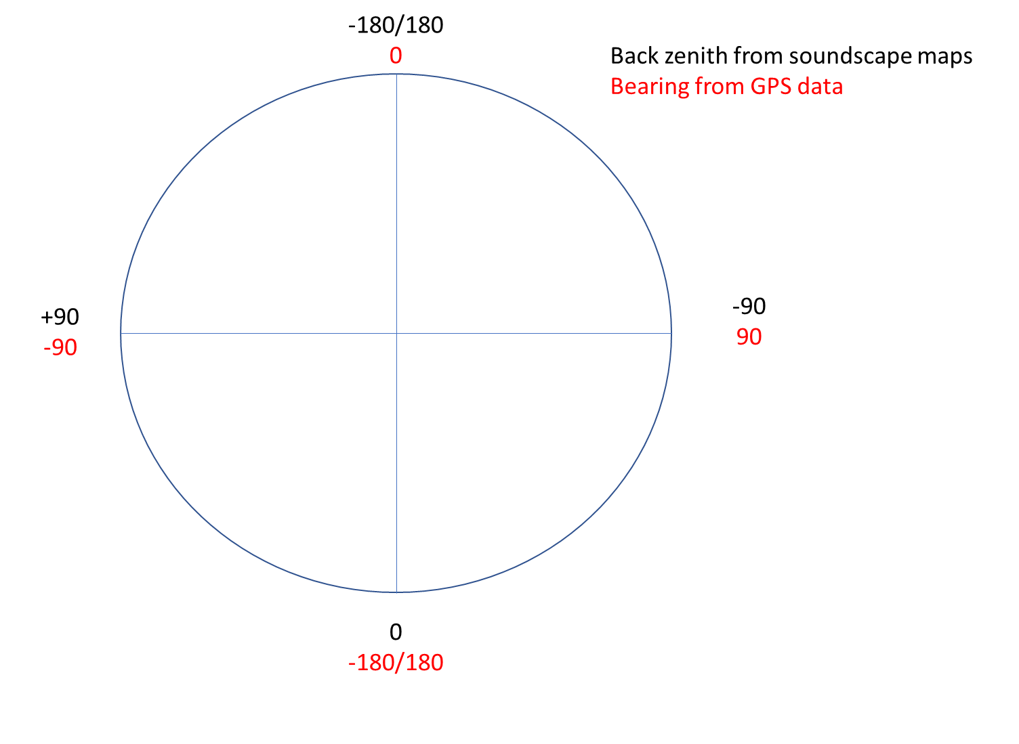

PCA-Cluster-report.Rmd <https://drive.google.com/file/d/1zpHUjqJNEalMwLsbwZ3FUzyJUcpwNMKk/view?usp=sharing>

PCA-Cluster-report-360deg.Rmd <https://drive.google.com/file/d/14WNdYnarR1ISP33-NlJEGZgG7p9dbAO9/view?usp=sharing>

Due to the heavy processing I had to divide the R markdown in two documents for the computer to be able to produce the output.

We have selected all the SPL data between 0 and 2000 km from the bird. Lines 55-84 in PCA-Cluster-report.Rmd. We have standardized each map with mean zero and std of 1 so we can compare all the maps. Because we want to compare and see if there are similar patterns. To do this we have removed from the database Gdist and the relative angle. Lines 89-90 in PCA-Cluster-report.Rmd. We produce and plot the PCAs to reduce the dimension of the data into few continuous variables containing the most important information in the data. Lines 101-110 in PCA-Cluster-report.Rmd. Then we perform the cluster analysis on the PCA results. For each cluster analysis we plot the dendrogram so as to identify how many clusters we should choose. However, for each case scenario, we have created 3, 4, 5 and 6 clusters and plot the IS pattern output for all.

The different scenarios are the following:

* Clusters created with **all decision map points**. Lines 119-211 in PCA-Cluster-report.Rmd.
* Clusters created for **males and females** independently. Lines 214-374 in PCA-Cluster-report.Rmd.
* Clusters created for the **different Trip_state** (out, mid, in). Lines 382-624 in PCA-Cluster-report.Rmd.
* Clusters created for **males and females during the different Trip_states**. Lines 629-1090 in PCA-Cluster-report.Rmd.

**PCA-clustering results**

PCA-Cluster-report.html <https://drive.google.com/file/d/1QbtceCMr81_vdUvnK-UXqq0PEDRgzmnW/view?usp=sharing> (for 30 and 90 degrees)

PCA-Cluster-report-360deg.html <https://drive.google.com/file/d/1iFCalUMoWthOPwfud3ZS8sAaWspkcZlt/view?usp=sharing> )for 360 degrees)

* **30 deg.** 
  + **All data.** Seems that 3 or 5 clusters is the best option (see the cluster dendrogram).
    - For 3 clusters most of the maps (2186) belong to clust2 for which the scaled SPL is around 0 with no differences in SPL neither with distance from the bird neither from the bird’s bearing angle. A few maps (732) belong to clust1 for which the SPL is lower than the average SPL. A minority of the maps (278) belong to clust3. Here, the SPL increases with distance from the bird reaching a maximum at around 1000km and then decreases again. Higher SPL are closer to the bird’s bearing than far from it (+/-15 deg from the bearing).
    - For 5 clusters most of the maps (1989) belong to clust2 for which the scaled SPL is around 0 a slightly increase of SPL when increasing the distance from the bird. A few maps (697) belong to clust1 for which the SPL is lower than the average SPL. A minority of the maps (124) belong to clust5. Here, the SPL increases with distance from the bird reaching a maximum at around 1000km and then decreases again. Higher SPL are closer to the bird’s bearing than far from it (+/-15 deg from the bearing). These three patterns are similar to those defined in the scenario with 3 clusters. Here, in addition there is clust3 and clust4 with almost 200 maps each. The patterns are a decrease and an increase in SPL with distance from the bird, respectively.
  + Different clusters for **males and females** to see if there are different soundscape map patterns. It seems that males are exposed to higher SPL than females. Seems that **4 clusters** is the best option (see the cluster dendrogram for each sex). Clust2 (860 and 1233, respectively) Here, the scaled SPL is around 0 with no differences in SPL neither with distance from the bird neither from the bird’s bearing angle. Then is clust1 (291 and 404 respectively), for which the SPL is lower than the average SPL. Clust3 and clust4 are different for males and females.
    - Males. Clust3 (88) the SPL decreases with distance from the bird, with really high SPL from 9 to 500km from the bird. Clust4 (103) the SPL increases with distance from the bird reaching a maximum at around 1000km and then decreases again. Higher SPL are closer to the bird’s bearing than far from it (+/-15 deg from the bearing).
    - Females. Clust3 (110) the SPL increases with distance from the bird. Clust4 (107) the SPL increases with distance from the bird reaching a maximum at around 500km and then decreases again reaching its minimum in the whole distance range beyond 1500km.
  + Different clusters for **different tris States (out, mid, ins)** to see if there are different soundscape map patterns. Seems that 4 clusters is the best option (see the cluster dendrogram) for out and mid, while 3 clusters for inside state trip.
    - **Out trip:** Clust2 (774) the scaled SPL is around 0 with no differences in SPL neither with distance from the bird neither from the bird’s bearing angle. Then is clust1 (233), for which the SPL is lower than the average SPL. Clust3 (66) the SPL decreases with distance from the bird, with higher SPL up to 500km from the bird. Clust4 (84) the SPL increases with distance from the bird reaching a maximum at around 1400km and then decreases again.
    - **Mid trip:** Clust2 (720) the scaled SPL is around 0 with a slightly decrease in SPL with distance from the bird. Then is clust1 (243), for which the SPL is lower than the average SPL. Clust3 (96) the SPL increases with distance from the bird. Clust4 (82) the SPL increases with distance from the bird reaching a maximum at around 700km and then decreases again. Higher SPL are closer to the bird’s bearing than far from it (+/-15 deg from the bearing).
    - **Ins trip:** 3 clusters. This is like the all-data scenario. For 3 clusters most of the maps (597) belong to clust2 for which the scaled SPL is around 0 with no differences in SPL neither with distance from the bird neither from the bird’s bearing angle. A few maps (230) belong to clust1 for which the SPL is lower than the average SPL. A minority of the maps (70) belong to clust3. Here, the SPL increases with distance from the bird reaching a maximum at around 1000km and then decreases again.
  + Different clusters for **different tris States (out, mid, ins) and for different sex**.

It seems that males are exposed to slightly higher SPL than females and that during the in part of the trip the SPL is also higher. However, the sample size for this particular cluster is really small. Due to the small map number for some cluster when doing more than 3 clusters, I think its better to stay with 3 clusters.

* + - Males:
      * OutTrip: For 3 clusters most of the maps (335) belong to clust2 for which the scaled SPL is around 0 with a slightly decrease in SPL with distance from the bird. A few maps (113) belong to clust1 for which the SPL is lower than the average SPL. A minority of the maps (44) belong to clust3. Here, the SPL increases with distance from the bird reaching a maximum at around 1000km and then decreases again. Higher SPL are closer to the bird’s bearing than far from it (+/-15 deg from the bearing).
      * MidTrip: most of the maps (316) belong to clust2 for which the scaled SPL is around 0 with a slightly decrease in SPL with distance from the bird. A few maps (100) belong to clust1 for which the SPL is lower than the average SPL. A minority of the maps (53) belong to clust3. Here, the SPL increases with distance from the bird reaching a maximum at around 1000km and then decreases again.
      * InTrip: most of the maps (264) belong to clust2 for which the scaled SPL is around 0. A few maps (82) belong to clust1 for which the SPL is lower than the average SPL. A minority of the maps (35) belong to clust3. Here, the SPL increases with distance from the bird reaching a maximum at around 1000km and then decreases again. Higher SPL towards the east of the bird’s bearing.
    - Females:
      * OutTrip: For 3 clusters most of the maps (484) belong to clust2 for which the scaled SPL is around 0. A few maps (114) belong to clust1 for which the SPL is lower than the average SPL. A minority of the maps (67) belong to clust3. Here, the SPL increases with distance from the bird reaching a maximum at around 1400km and then decreases again.
      * MidTrip: most of the maps (476) belong to clust2 for which the scaled SPL is around 0 with a slightly increase in SPL with distance from the bird. A few maps (147) belong to clust1 for which the SPL is lower than the average SPL. A minority of the maps (49) belong to clust3. Here, the SPL decreases with distance from the bird.
      * InTrip: most of the maps (339) belong to clust2 for which the scaled SPL is around 0. A few maps (140) belong to clust1 for which the SPL is lower than the average SPL. A minority of the maps (37) belong to clust3. Here, the SPL increases with distance from the bird reaching a maximum at around 1000km and then decreases again. Higher SPL towards the east of the bird’s bearing.
* **90 deg.** 
  + **All data.** Seems that 5 clusters is the best option (see the cluster dendrogram).
    - For 5 clusters most of the maps (2049) belong to clust2 for which the scaled SPL is around 0. A few maps (698) belong to clust1 for which the SPL is lower than the average SPL. Then the rest of the maps belong to the other three clusters. Clust3 (169), SPL increases towards the east and decreases towards the west of the bird’s bearing. CLust4 SPL decreases with distance from the bird reaching a maximum around 200km. Clust5 SPL increases with distance from the bird reaching a maximum around 1500km.
  + Different clusters for **males and females** to see if there are different soundscape map patterns. It seems that males are exposed to higher SPL than females. Seems that 5 clusters is the best option (see the cluster dendrogram for each sex). Clust2 (828 and 1182, respectively) Here, the scaled SPL is around 0. Then is clust1 (286 and 402 respectively), for which the SPL is lower than the average SPL. Clust5 (33 and 58, respectively) SPL decreases with distance from the bird, having the greatest SPL up to a 100km (males are exposed to higher SPL than females). Clust3 and clust4 are different for males and females.
    - Males. Clust3 (94) the SPL decreases with distance from the bird. Clust4 (101) the SPL increases with distance from the bird towards the east side of the bird’s bearing reaching a maximum at around 1400km.
    - Females. Clust3 (126) the SPL decreases with distance from the bird towards the west of the bird’s bearing. Clust4 (86) the SPL increases with distance from the bird towards the west of the bird’s bearing, reaching a maximum at around 1500km and -25deg.
  + Different clusters for **different tris States (out, mid, ins)** to see if there are different soundscape map patterns. Seems that 4 clusters is the best option (see the cluster dendrogram) for out and mid, while 3 clusters for inside state trip.
    - **Out trip:** Clust2 (792) the scaled SPL is around 0 with no differences in SPL neither with distance from the bird neither from the bird’s bearing angle. Then is clust1 (222), for which the SPL is lower than the average SPL. Clust3 (63) the SPL decreases with distance from the bird, with higher SPL up to 250km from the bird. Clust4 (80) the SPL increases with distance from the bird reaching a maximum at around 1500km and then decreases again.
    - **Mid trip:** Clust2 (736) the scaled SPL is around 0 with a slightly decrease in SPL with distance from the bird towards the west side of the bird’s bearing. Then is clust1 (263), for which the SPL is lower than the average SPL. Clust3 (79) the SPL increases with distance from the bird towards the west side of the bird’s bearing. Clust4 (63) the SPL increases with distance from the bird reaching a maximum at around 500km and then decreases again reaching its minimum SPL at 2000km.
    - **Ins trip:** 3 clusters. This is like the all-data scenario. For 3 clusters most of the maps (583) belong to clust2 for which the scaled SPL is around 0 with no differences in SPL neither with distance from the bird neither from the bird’s bearing angle. A few maps (233) belong to clust1 for which the SPL is lower than the average SPL. A minority of the maps (81) belong to clust3. Here, the SPL increases with distance from the bird reaching a maximum at around 1000km and then decreases again.
  + Different clusters for **different tris States (out, mid, ins) and for different sex**.

It seems that males are exposed to slightly higher SPL than females and that during the in part of the trip the SPL is also higher. However, the sample size for this particular cluster is really small. Due to the small map number for some cluster when doing more than 3 clusters, I think its better to stay with 4 clusters.

* + - Males: out and mid trip very similar patterns.
      * OutTrip: For 4 clusters most of the maps (314) belong to clust2 for which the scaled SPL is around 0. A few maps (102) belong to clust1 for which the SPL is lower than the average SPL. A minority of the maps (44) belong to clust3. Here, the SPL decreases with distance from the bird. Clust4 (32) SPL increases with distance from the bird towards the east side of its bearing, reaching a maximum at around 1400km and then decreases again with distance.
      * MidTrip: most of the maps (305) belong to clust2 for which the scaled SPL is around 0. A few maps (100) belong to clust1 for which the SPL is lower than the average SPL. A minority of the maps (45) belong to clust3. Here, the SPL decreases with distance from the bird. Clust4 (19) SPL increases with distance from the bird towards the east side of its bearing, reaching a maximum at around 1400km and then decreases again with distance.
      * InTrip: most of the maps (240) belong to clust2 for which the scaled SPL is around 0. A few maps (95) belong to clust1 for which the SPL is lower than the average SPL. A minority of the maps (22) belong to clust3. Here, the SPL increases with distance from the bird towards the east side of the bird’s bearing reaching a maximum at around 1400km and then decreases again. Clust4 (24) SPL decreases with distance from the bird having a maximum up to 800 km.
    - Females:
      * OutTrip: For 4 clusters most of the maps (469) belong to clust2 for which the scaled SPL is around 0. A few maps (118) belong to clust1 for which the SPL is lower than the average SPL. A minority of the maps (38) belong to clust3. Here, the SPL decreases with distance from the bird towards the west side of the bird’s bearing. Clust4 (40) SPL increases with distance from the bird towards the east side of its bearing, reaching a maximum at around 1500km and then decreases again with distance.
      * MidTrip: most of the maps (447) belong to clust2 for which the scaled SPL is around 0. A few maps (149) belong to clust1 for which the SPL is lower than the average SPL. A minority of the maps (41) belong to clust3. Here, the SPL decreases towards the west of the bird and increases towards the east of the bird’s bearing. Clust4 (35) SPL increases with distance from the bird towards the east side of its bearing, reaching a maximum at around 1400km and then decreases again with distance, and decreases towards the west side of the bird’s bearing.
      * InTrip: most of the maps (319) belong to clust2 for which the scaled SPL is around 0 and slightly increases with distance towards the west side of the bird’s bearing. A few maps (132) belong to clust1 for which the SPL is lower than the average SPL. A minority of the maps (34) belong to clust3.where the SPL decreases with distance from the bird towards the west side of the bird’s bearing. Clust4 (31) SPL increases with distance from the bird towards the west side of the bird’s bearing, having a maximum up to 1200 km.
* **360 deg.** 
  + **All data.** Seems that 5 clusters is the best option (see the cluster dendrogram).
    - For 5 clusters most of the maps (1962) belong to clust2 for which the scaled SPL is around 0. A few maps (574) belong to clust1 for which the SPL is lower than the average SPL. Then the rest of the maps belong to the other three clusters. Clust3 (224), SPL increases towards the east and decreases towards the west of the bird’s bearing. CLust4 (243) SPL decreases towards the east and increase towards the west of the bird’s bearing. Clust5 (193) SPL decreases with distance from the bird, higher SPL are around the bird’s bearing and decreases with increasing the angle from the bird’s bearing.
  + Different clusters for **males and females** to see if there are different soundscape map patterns. It seems that males are exposed to higher SPL than females. Seems that 5 clusters is the best option (see the cluster dendrogram for each sex).
    - Males. Clust2 (792) the scaled SPL is around 0. Then is clust1 (263), for which the SPL is lower than the average SPL and increases with distance towards the west side of the bird’s bearing. Then the rest of the maps belong to the other three clusters. Clust3 (119) the SPL decreases towards the west side of the bird’s bearing and increases towards the west. Clust4 (112) the SPL increases with distance from the bird towards the east side of the bird’s bearing and decreases towards the west. Clust5 (56) SPL decreases with distance from the bird, having the greatest SPL up to a 100km towards the east of the bird’s bearing.
    - Females. Clust3 (1134) the scaled SPL is around 0. Then is clust1 (308), for which the SPL is lower than the average SPL. Then the rest of the maps belong to the other three clusters. Clust2 (169) the SPL decreases towards the east side of the bird’s bearing and increases towards the west. Clust4 (155) the SPL increases with distance from the bird towards the east side of the bird’s bearing and decreases towards the west. Clust5 (88) SPL decreases with distance from the bird and with relative angle from the bird’s bearing, having the greatest SPL up to a 1500km and from 0 to -90deg.
  + Different clusters for **different tris States (out, mid, ins)** to see if there are different soundscape map patterns. Seems that 5 clusters is the best option (see the cluster dendrogram) for out and in, while 4 clusters for mid state trip.
    - * **OutTrip**: For 4 clusters most of the maps (314) belong to clust2 for which the scaled SPL is around 0. A few maps (102) belong to clust1 for which the SPL is lower than the average SPL. Then the rest of maps are within the other three clusters. Clust2 (102) the SPL decreases towards the west and increases towards the east. Clust4 (74) the SPL increases towards the west and decreases towards the east. Clust5 (66) the SPL decreases with distance from the bird.
      * **MidTrip**: most of the maps (305) belong to clust2 for which the scaled SPL is around 0. A few maps (100) belong to clust1 for which the SPL is lower than the average SPL. A minority of the maps (45) belong to clust3. Here, the SPL decreases with distance from the bird. Clust4 (19) SPL increases with distance from the bird towards the east side of its bearing, reaching a maximum at around 1400km and then decreases again with distance.
      * **InTrip**: most of the maps (553) belong to clust2 for which the scaled SPL is around 0. A few maps (184) belong to clust1 for which the SPL is lower than the average SPL. Then the rest of maps are within the other three clusters. Clust3 (49) the SPL decreases towards the east and increases towards the west. Clust4 (85) the SPL increases towards the east and decreases towards the west. Clust5 (26) the SPL decreases with distance from the bird.
  + Different clusters for **different tris States (out, mid, ins) and for different sex**.

It seems that males are exposed to slightly higher SPL than females and that during the in part of the trip the SPL is also higher. However, the sample size for this particular cluster is really small. Due to the small map number for some cluster when doing more than 3 clusters, I think its better to stay with **4 clusters**.

* + - Males: out and mid trip very similar patterns.
      * OutTrip: For 4 clusters most of the maps (378) belong to clust2 for which the scaled SPL is lower than the average SPL. Then the rest of maps are within the other three clusters. A few maps (49) belong to clust1 for which the SPL decreases towards the west of the bird’s bearing and increases towards the east. Clust3 (39) the SPL decreases towards the east and increases towards the west. Clust4 (26) the SPL decreases with increasing distance having a maximum value up to 500km towards the east of the bird’s bearing.
      * MidTrip: For 4 clusters most of the maps (292) belong to clust2 for which the scaled SPL is lower than the average SPL. Then the rest of maps are within the other three clusters. A few maps (92) belong to clust1 for which the SPL d is lower than the average SPL. Clust3 (41) the SPL decreases towards the west and remains constant towards the east. Clust4 (44) the SPL decreases with increasing distance having a maximum value up to 500km towards the west of the bird’s bearing.
      * InTrip: For 4 clusters most of the maps (288) belong to clust2 for which the scaled SPL is lower than the average SPL. Then the rest of maps are within the other three clusters. A few maps (31) belong to clust1 for which the SPL decreases towards the east of the bird’s bearing and increases towards the west. Clust3 (45) the SPL decreases towards the west and increases towards the east. Clust4 (17) the SPL decreases with increasing distance except at a bearing **of +30 in which the SPL remains high**.
    - Females: In and mid trip very similar
      * OutTrip: For 4 clusters most of the maps (446) belong to clust2 for which the scaled SPL is around 0. Then the rest of maps are within the other three clusters. A few maps (112) belong to clust1 for which the SPL is lower than the average SPL. Clust3 (68) the SPL decreases towards the west and remains constant towards the east. Clust4 (39) the SPL decreases towards the east and slightly increases towards the west
      * MidTrip: most of the maps (494) belong to clust2 for which the scaled SPL is around 0. A few maps (113) belong to clust1 for which the SPL is lower than the average SPL. A minority of the maps (35) belong to clust3. Here, the SPL decreases towards both east and west side of the bird’s bearing and with distance from the bird. Clust4 (30) SPL decreases with distance from the bird towards the west, and slightly increases towards the east reaching a maximum at around 800km +50 deg.
      * InTrip: most of the maps (319) belong to clust2 for which the scaled SPL is around 0. A few maps (133) belong to clust1 for which the SPL is lower than the average SPL. A minority of the maps (28) belong to clust3. Here, the SPL decreases towards both east and west side of the bird’s bearing and with distance from the bird. Clust4 (36) SPL decreases with distance from the bird towards the west, and slightly increases towards the east reaching a maximum at around 1200km.

**Other Possible future avenues that we have discussed in previous meetings:**

In relation with this analysis, it would be good to test that if the direction taken during the first point of each travelling bout and the associated IS characteristics, are similarly constant over time during that travelling period (i.e., until the next searching period). The problem I see with this is that it is more complex as we will need to deal with autocorrelation. And another problem that the results are negative…

So, possible different ways of analysing the data from zero would be.

* **Resource step selection function**: <https://terpconnect.umd.edu/~egurarie/teaching/SpatialModelling_AKTWS2018/6_RSF_SSF.html>
* Step selection function:

Both step selection function and resource step selection function could seem promising ways of moving forward, also suggested by Mathieu. I have never used them myself, but I have read that these models can include interactions with predictors to model how movement is influenced by habitat. They have been used to study habitat selection and have the potential to depict resource selection at multiple spatial and temporal scales. It could help to find what covariates albatross are either selecting or avoiding. In short it does compare environmental attributes of observed steps with alternative random steps taken from the same starting point.

However, it seems that we have already talked about these models a while ago and we decided not to use them. I do not really recall why we decided that, do you Sam? But my concern with these models is that the IS below the bird is the IS that the bird is perceiving from below but not from other places. I mean, the bird is experiencing all of the IS that is represented in the map, not just what is below it. Do not know if we will be able to incorporate the cone thing or something similar within this step selection functions. What do you think?

**Appendix A. Sound Pressure level propagation.**

Due to the propagation model, the highest microbarom sound pressure level to the soundscape is relatively close to the bird (this will be within 200-500 km away from the bird).

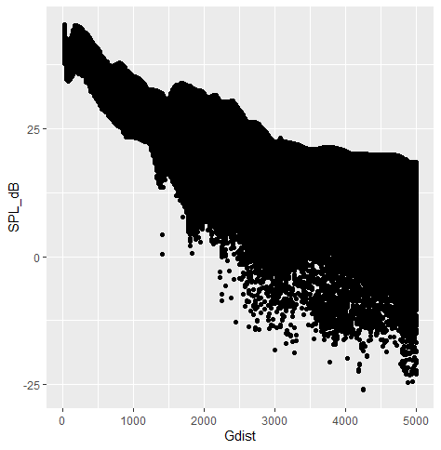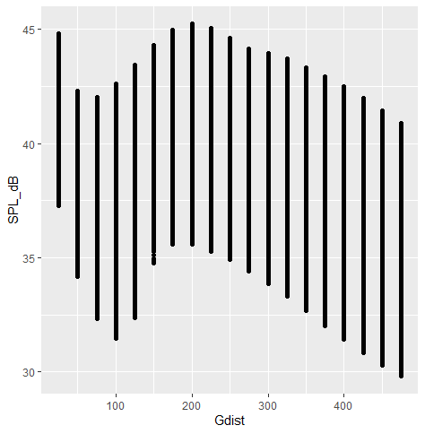

Fig. 1: Attenuation curves versus distance: SPL in dB in relation to the distance from the bird in km (Gdist) for 5 consecutive hourly GPS locations (and therefore 5 consecutive soundscape maps) of one tripID. For each soundscape map, it is plotted the distance from the bird to all the points in the map (Gdist) and the exact SPL in dB measured at all those points. Note how the trend is that SPL decreases with the distance from the bird, having a max around 200-250 km from the bird (see figure on the right which is a zoom of the figure on the left). This means that the far-field sources do contribute significant to the total SPL level, we can not only focus on the nearfield sources.

**Appendix B. Division of foraging trips into outward, middle, and inward stages.**

Ewan Wakefield et al 2009 (<https://esajournals.onlinelibrary.wiley.com/doi/abs/10.1890/07-2111.1>) divided trip stage as follows:

We categorized tracking locations as having been recorded during the outward, middle, or inward stage of foraging trips. Although central-place foraging trips are often regarded as divisible in this way (Orians and Pearson 1979), in albatrosses the distinction between commuting and foraging varies considerably with species and breeding stage (Weimerskirch et al. 1997b; British Antarctic Survey [BAS], unpublished data). Furthermore, at the individual level it is difficult to objectively identify the transition between such behaviors (BAS, unpublished data). Rather than adopting an arbitrary division on a case-by-case basis, we determined the stage of trips at which these transitions typically occur at the population level. In short, foraging trips were divided into beginning, middle, and return stages at the level of breeding stage within species as follows: For each location within a foraging trip, we calculated *d*col/*d*max, the distance from the colony as a proportion of the maximum distance from the colony reached during that trip. Similarly, we calculated the time elapsed since the beginning of the trip as a proportion of the total trip time elapsed *t*/*t*max. The total variance in *d*col/*d*max for all locations occurring before *t*/*t*max was then plotted against *t*/*t*max (e.g., Fig. B1). At all stages and in all species this curve rose monotonically from zero before leveling off or reaching a point of inflexion. The value of *t*/*t*max at this point was determined graphically. We classified tracking locations as having been recorded during outward trips if they occurred before the end of the monotonic phase. The onset of return trips was determined in a similar manner by plotting the total variance in d/dmax for all locations occurring after *t*/*t*max against *t*/*t*max and identifying the value of *t*/*t*max at which a monotonic decrease in variance began.

**Rscript:** Full_script_data2013GPS_IS_model.R, lines 561-659

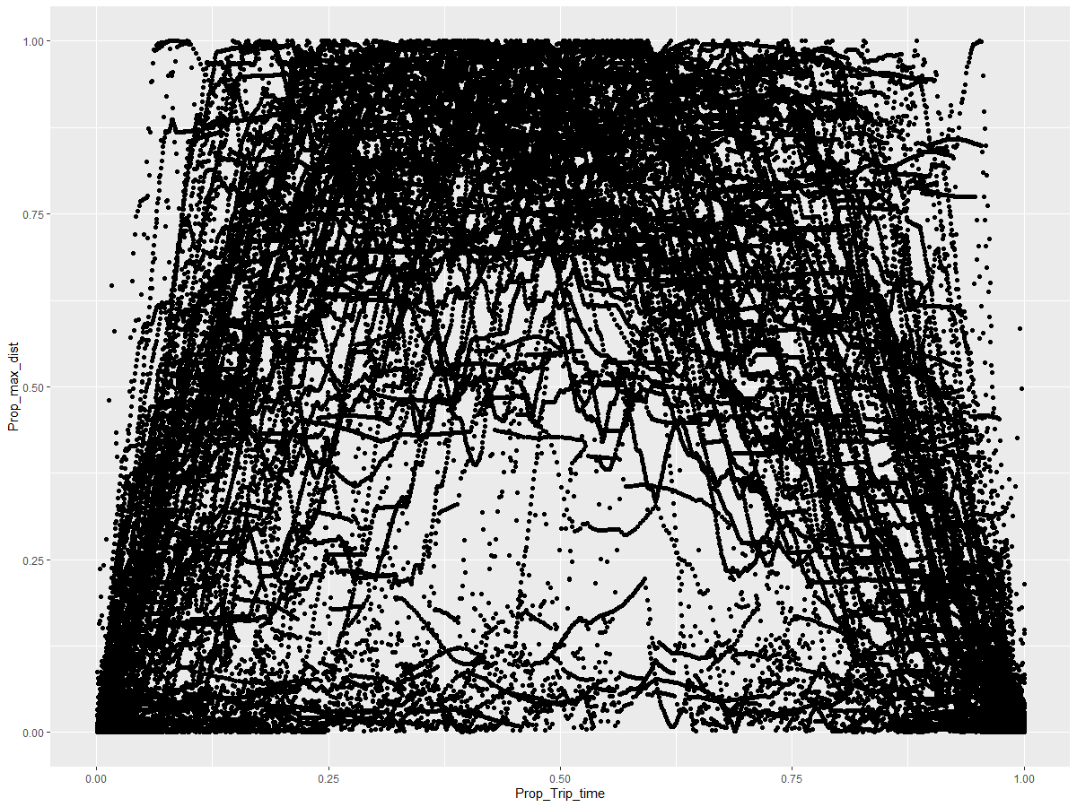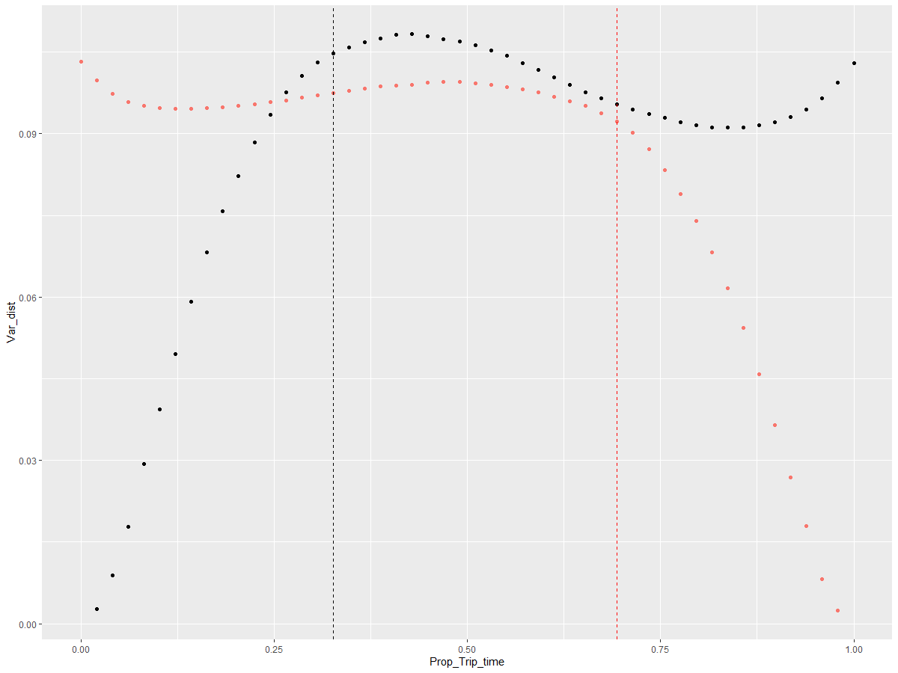

FIG. Examples of plots used to estimate divisions between outward, middle, and inward stages of foraging trips. Upper panel: distance from colony as a proportion of maximum distance from colony reached (*d*col*/d*max) during foraging trips vs. proportion of total trip time elapsed (*t/t*max) (89 birds, 89 trips). Lower panel: Variance in *d/d*max for all locations < *t/t/*max vs. *t/t*max (solid line) and variance in *d/d*max for all locations > *t/t/*max vs. *t/t*max (broken line). Vertical lines indicate the estimated divisions between outward, middle, and return stages of foraging trips.